សាកលវិទ្យាល័យភូមិន្ទភ្នំពេញ

**Royal University of Phnom Penh**

មហាវិទ្យាល័យវិស្វកម្ម

**Faculty of Engineering**

ដេប៉ាតឺម៉ង់ វិស្វកម្មទូរគមនាគមន៍និង​អេឡិចត្រូនិច

Department of Telecommunication and Electronic Engineering

**Face recognition and Attendance system**

**Components report**

**Group 6**

**Sokhom Panhavathana**

**Chheng Sreymeas**

**February 2023**

**Table of Contents**

1. **Components** 
   1. **ESP32 Cam**
   2. **USB to serial**
   3. **PC screen**
2. **Components**

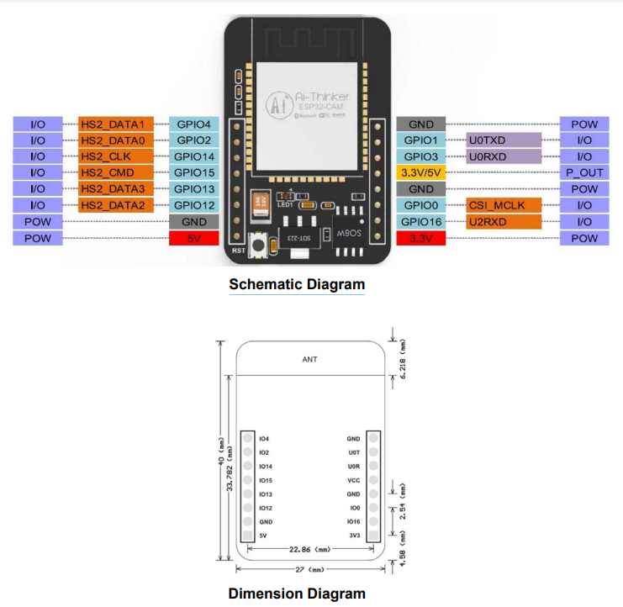**1.1 ESP32 Cam**

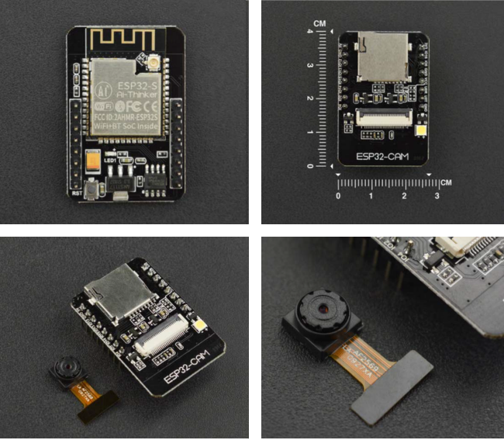

* 1. **USB to Serial**

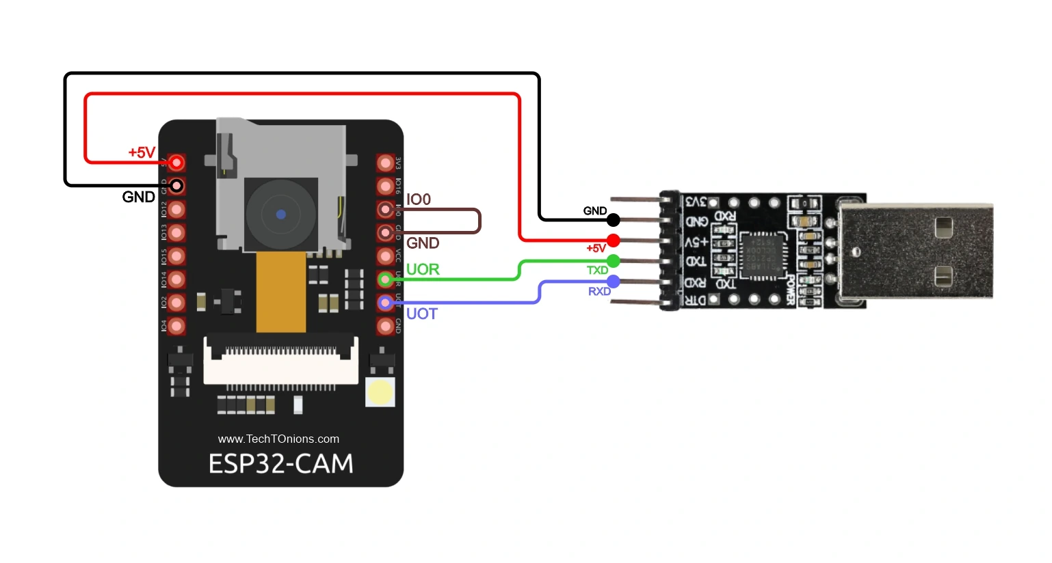

**Use this USB to serial to connect ESP32 Cam with PC.**